**Topic:** Archimedes’ Masterpiece: On the Sphere and the Cylinder

**Notes on Topic:** Archimedes also wrote on the geometry of spirals, conoids and spheroids and provided a remarkable means of calculating the area under a parabola by summing a certain infinite geometric series

Archimedes was very far ahead of his time, covering topics of calculus as early as 200s BC  
His greatest masterpiece was *On the Sphere and the Cylinder* a two volume book about the volumes and surface areas of spheres and related bodies, achieving for three dimensional solids what *Measurement of a Circle* had done for two dimensional figures

As we saw from Euclid, he knew that the volume of a Sphere was to the cube of its diameter by a constant m, so V = mD^3 (“spheres are to one another in triplicate ratio of their respective diameter” final proposition of Book XII)

This book also started with a list of definitions and postulates and from there derived even more sophisticated theorems

The first proposition was “If a polygon is circumscribed about a circle, then the perimeter of the polygon is greater than the circumference of the circle”

**Proposition 13**: “The surface of any right circular cylinder excluding the bases is equal to a circle whose radius is a mean proportional between the side of the cylinder and the diameter of the base”

Notes: in modern terminology -- lateral surface (cylinder of radius r and height h) = area (circle with radius x). Where $\frac{h}{x}=\frac{x}{2r}$, from that it follows that $x^{2}=2rh$ so we get

Lateral Surface (cylinder) = Area (circle) = $πx^{2}=2πrh$

Archimedes continued with a few more like-sounding propositions finally reaching the big result, surface area of a sphere  
Archimedes used a similar approach using the method of exhaustion and approximating the surface area through using cones and frusta of cones whose surface area had previously been determined, the book does not have the space to get into covering Archimedes argument, but rather just gives us the final, important result

He had proven, **Proposition 33**: The surface of any sphere is equal to four times the greatest circle in it

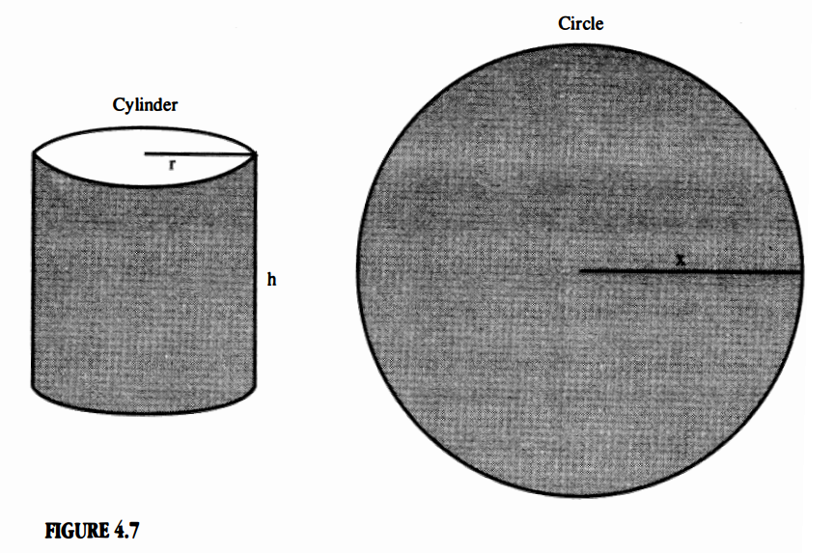

He proved it using his favorite method, showing that it is impossible for the sphere’s surface to be any more than four times the largest circle’s area, and impossible to be any less than four times as well, showing that it is necessary to be equal to four times the largest circle

We know that the sphere’s greatest circle area is through the hemisphere, then we can translate the formula into surface area (sphere) = $4πr^{2}$  
The sophistication of Archimedes math seemed to anticipate the ideas of modern integral calculus

Many people are bothered by the fact that the sphere’s surface is exactly four times the hemisphere area, why exactly 4?

Archimedes wrote, in a letter to Dositheus, a scholar in Alexandria, that he did not search for this great discovery, and he did not invent or create this fact, but rather stumbled upon a fortunate discovery   
  
**Proposition 34**: Any sphere is equal to four times the cone which has its base equal to the greatest circle in the sphere and its height equal to the radius of the sphere

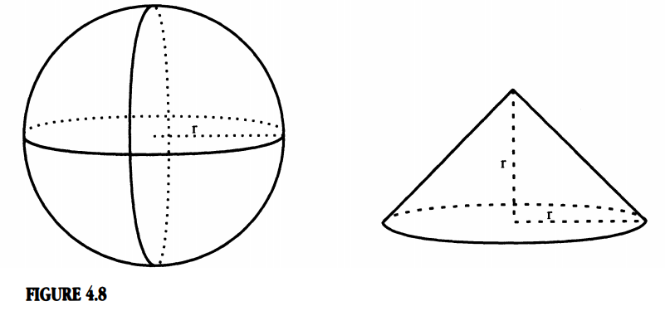

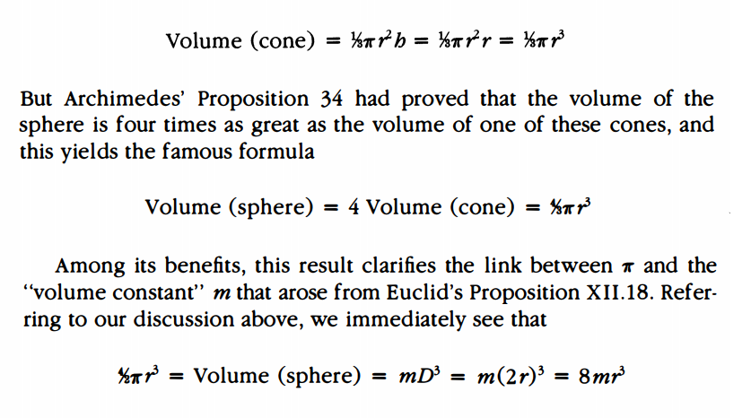

Again Archimedes expressed the volume of the sphere in non-algebraic terms, but rather terms that involved simpler geometric figures whose volume had already been determined  
This also clarifies the relationship between pi and the volume constant m, some easy algebra shows that m = pi/6  
  
Immediately after Prop 33 & 34, Archimedes commented on a cylinder circumscribed about the sphere.

He asserted that the cylinder is half again as large as the sphere in both volume and surface area.

Notice, a cylinder circumscribed about a sphere has radius r, as does the sphere, and height 2r.  
Total cylinder surface = $2πrh+πr^{2}+πr^{2}$

= $2πr(2r)+2πr^{2}$ = $6πr^{2}$

= $\frac{3}{2}(4πr^{2})$

= $\frac{3}{2}$ (spherical surface)

Thus half again a sphere.  
The same algebraic argument goes for volume.   
Thus sums up the treatise we are examining.  
  
Archimedes was doing mathematics thousands of years ahead of his time, never again has there been a mathematician this far ahead of his time.

Not until the development of calculus years later, did people advance the understanding of volumes and surface areas of solids beyond its Archimedean foundation.  
Voltaire wrote, “There is more imagination in the head of Archimedes than in that of Homer.”

**Additional Suggested Reading**: Epilogue, Chapter 4

**Assignment:** Homework Problem 62, 65